Experiment-1
AIM: Create a web page using structure tags to display a sample message
Code:
<!doctype html>
<html>
<head>
<title> </title>
</head>
<body bgcolor="#E0E0E0">
<h1> <center> MAGGIE RECIPE! </center> </h1>
<hr>
<h3> Ingredients Needed: </h3>
<pre>
- 2 Packs of Maggie
- Finely Diced white Onion (1 bulb)
- 1 Chopped Tomato
- 1 tbsp Ginger-Garlic Paste
- 2 tbsp Soy sauce
- Salt, red chilli powder, Black Pepper, Dried mango Powder
- Vegetable Oil
</pre>
<h3> Directions: </h3>
<pre>
<h5> <u> Step-1 </u> </h5> Boil the maggie till it's half cooked and drain it while saving about half a cup of the starchy water.
<h5> <u> Step-2 </u> </h5> In a different pan, heat the oil and add the ginger-garlic paste. Stir it around a bit till aromatic and add the onions and tomato.
<h5> <u> Step-3 </u> </h5> Saute them around till the tomato starts to sweat and add the spices according to taste.
<h5> <u> Step-4 </u> </h5> Stir fry the mix a lil to get the flavour out and pour the starch water we saved some time ago.
<h5> <u> Step-5 </u> </h5> Let it come to a roling boil beofre adding our half cooked noodles. Mix and toss them to thoroughly coat every single strand.
<h5> <u> Step-6 </u> </h5> Pour the soy sauce around the edges of the pan and mix it a lil.
<h5> <u> Step-7 </u> </h5> Serve it while it's hot with a garnish of thinly sliced cucumber or cabbage on top.
<h5> <u> Tip </u> Add cheese or a tbsp of heavy cream (whatever you prefer) for a smoother, creamier texture.
</pre>
<img src="D:\HTML\Masala-Maggi-Recipe.png" width="500" height="250" alt="image of a bowl of maggi"> </body>
</html>
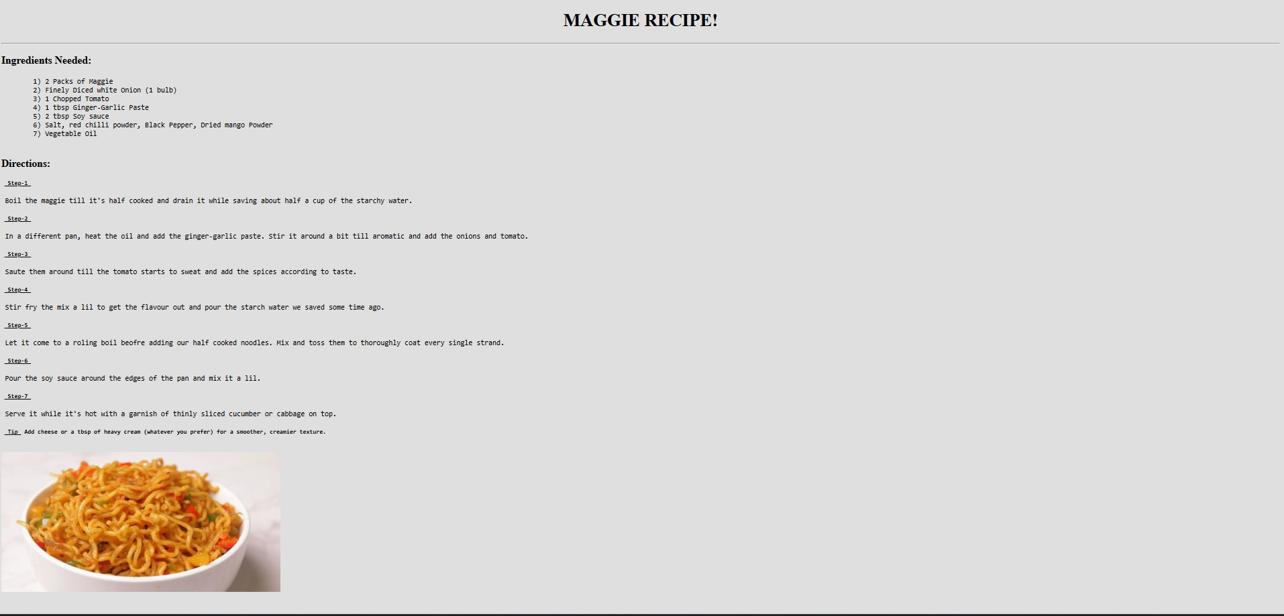

Experiment-2
Aim: Implementation of ordered and unordered list tags
Code:
<!doctype html>
<html>
<head>
</head>
<body bgcolor = "E0E0E0">
<h1> <center> Appetizers! </center> </h1>
<hr>
<pre>
<ul>
<li>Samosa | 20/-</li>
<li>Khaman Dhokla | 90/-</li>
<li>Pakora Platter | 140/-</li>
<li>Paneer Tikka | 140/-</li>
<li>Chicken Tandoori | 200/-</li>
<li>Seekh kebab | 180/-</li>
<li>Aloo Tikki | 50/-</li>
<li>Bhel Puri | 45/-</li>
<li>Papdi Chaat | 50/-</li>
<li>Gobi 65 | 175/-</li>
<li>Chicken 65 | 220/-</li>
<li>Chilli Paneer | 150/-</li>
<li>Idli Sambhar | 60/-</li>
<li>Masala Vada  </ul>  </pre>  <h1> <center> Main Course! </center> </h1>  <hr>  <pre> <ul>  <li> <b> <u>Paneer Dishes </u> </b> </li>  <ol> | 50/-</li>
<li>Palak Paneer | 210/-</li>
<li>Paneer Butter Masala | 210/-</li>
<li>Paneer do pyaza | 200/-</li>
<li>Shahi Paneer | 240/-</li>
<li>Malai Paner | 310/-</li>
<li>Kadhai Paneer | 210/-</li>
</ol>
<li> <b> <u>Lentil Dishes </u> </b> </li>
<ol>
<li>Dal Makhani | 175/-</li>
<li>Dal Tadka | 160/-</li>
<li>Dal Fry | 190/-</li>
<li>Chana Dal | 150/-</li>
<li>Gujrati Dal | 200/-</li>
<li>Dal Palak  </ol>  <li> <b> <u>Chicken dishes </u> </b> </li>  <ol> | 150/-</li>
<li>Butter Chicken | 350/-</li>
<li>Chicken Tikka Masala | 315/-</li>
<li>Tandoori chicken | 320/-</li>
<li>Chicken Biryani | 385/-</li>
<li>Kadhai chicken | 330/-</li>
<li>Chicken 65 | 350/-</li>
<li>Chilli Chicken  </ol>  <li> <b> <u>Tandoori Meats </u> </b> </li>  <ol> | 350/-</li>
<li>Tandoori Fish Tikka | 400/-</li>
<li>Mutton Seekh kebab | 410/-</li>
<li>Marinated Tandoori Platter  </ol>  <li> <b> <u>Breads</u> </b> </li>  <ol> | 550/-</li>
<li>Naan | 35/-</li>
<li>Roti | 15/-</li>
<li>Parantha  </ol>  </ul>  </pre>  <h1> <center> Beverages! </center> </h1>  <hr>  <pre>  <ul> | 25/-</li>
<li>Lassi | 60/-</li>
<li>Masala Chaas | 70/-</li>
<li>Thandai | 80/-</li>
<li>Fresh Lime Soda | 90/-</li>
<li>Jal Jeera | 90/-</li>
<li>Rose Milk  </ul>  </pre>  <h1> <center> Sweet Dishes! </center> </h1>  <hr>  <pre>  <ul> | 110/-</li>
<li>Gulab Jamun | 35/-</li>
<li>ChocolateFudge | 210/-</li>
<li>Carrot Cake | 240/-</li>
<li>Kulfi | 75/-</li>
<li>Rice Pudding | 110/-</li>
</ul>
</pre>
Result:
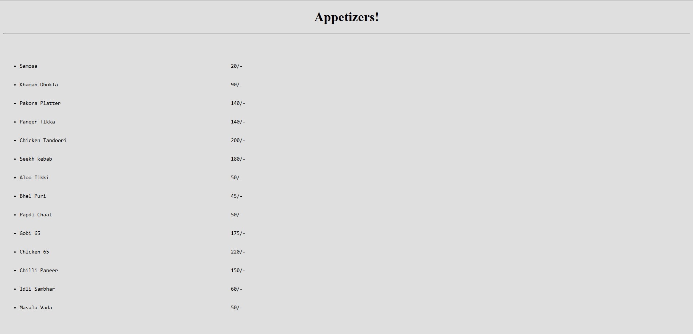


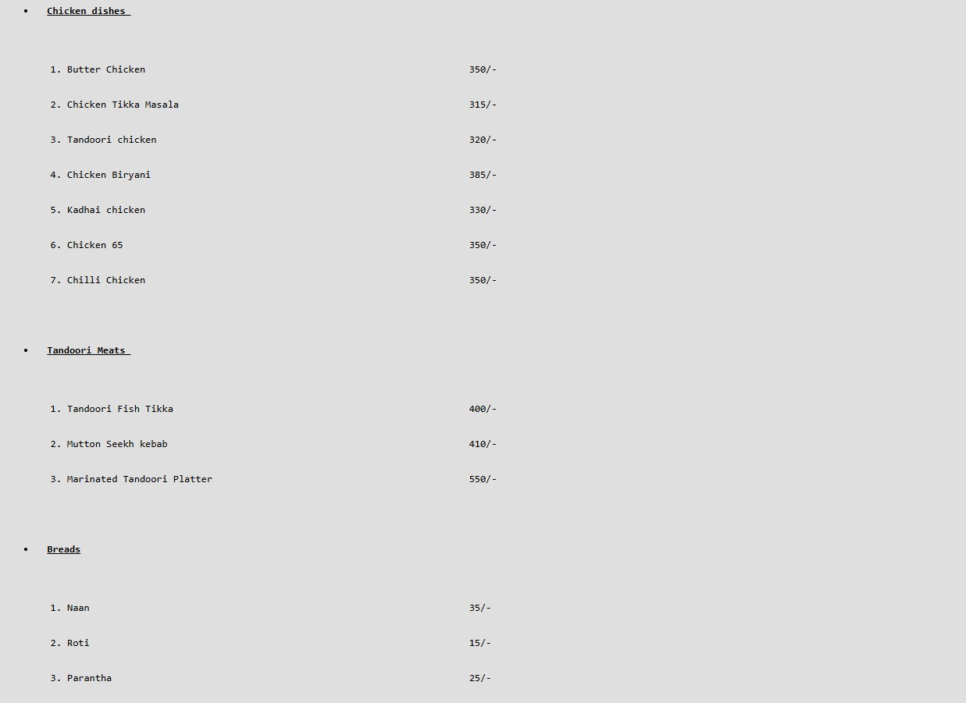

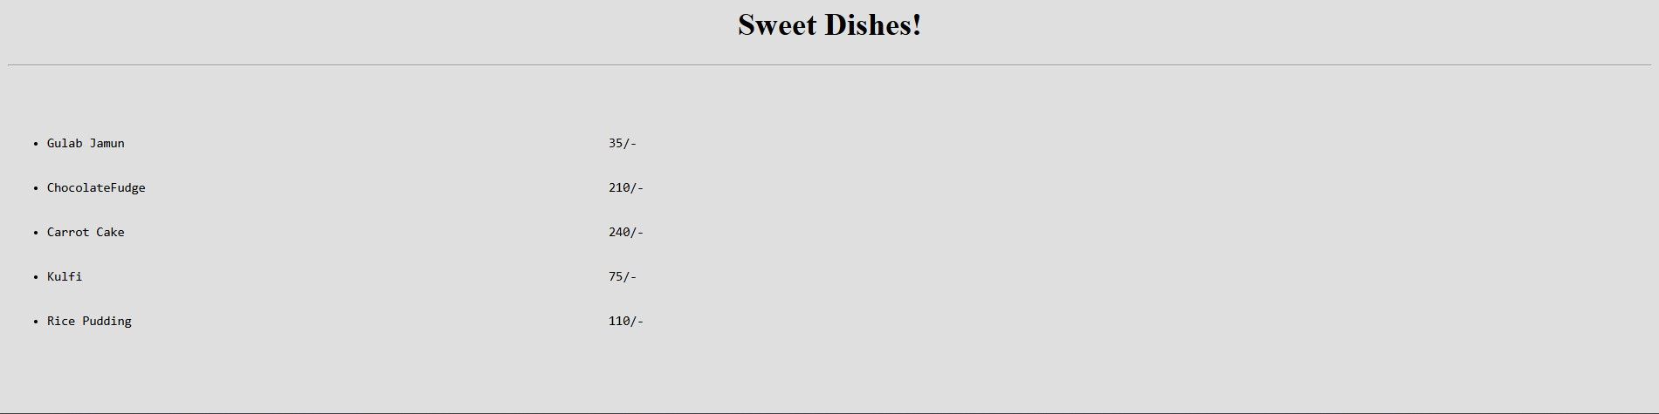

Experiment-3
Aim: Utilization of style tag and some format tags
Code:
<!DOCTYPE html>
<html>
<head>
<title>Pyramids of Giza</title>
<style> h1 { text-align: center;
} img { display: block; margin: 0 auto;
}
</style>
</head>
<body bgcolor=E0E0E0>
<h1>Pyramids of Giza</h1>
<img src="https://upload.wikimedia.org/wikipedia/commons/e/e3/Kheops-Pyramid.jpg" alt="The Pyramids of Giza" width="400">
<pre><p style="background-color: blanchedalmond;">
The <b>Pyramids of Giza</b> are ancient monuments near Cairo, Egypt.<br>
They were built over 4,500 years ago as royal tombs for the pharaohs Khufu, Khafre, and Menkaure.
The largest pyramid, built for Khufu, is the <b>Great Pyramid</b>.<br>
All three pyramids are made of limestone blocks and are known for their huge size and perfect shape. When first built, the pyramids were covered in a smooth, fine white limestone casing, causing them to gleam in the sun.
The Pyramids of Giza are the <b>last surviving Wonder of the Ancient World</b> and symbolize the brilliance of ancient Egyptian culture.
The Giza complex also features the Great Sphinx, a famous statue that is part of the overall pyramid complex. </p> </pre>
</body> </html>
Result:

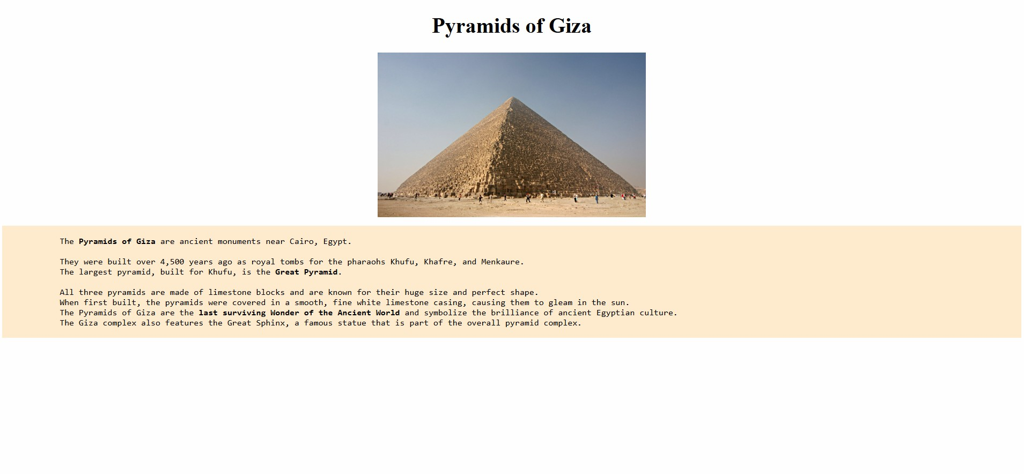

Experiment-4
Aim: Understanding table tag
Code:
<!DOCTYPE html>
<html>
<head>
<title>Time Table</title>
<style> table
{ text-align: center;
}
</style>
</head>
<body>
<table border="6">
<tr>
<th> Day</th></th>
<th>8-9 AM</th>
<th>9-10 AM</th>
<th>10-11 AM</th>
<th>11-12 PM</th>
<th>12-1 PM</th>
<th>1-2 PM</th>
<th>2-3 PM</th>
<th>3-4 PM</th>
<th>4-5 PM</th>
<th>5-6 PM</th>
</tr>
<tr>
<td>Monday</td>
<td colspan=2>C101</td><td colspan=2>AM101</td><td colspan=2></td>
<td colspan=2>EC105</td><td colspan=2></td>
</tr>
<tr>
<td>Tuesday</td>
<td colspan=2>AEC/VAC</td><td>EC105</td><td></td><td></td><td></td>
<td>CO101 (P)</td><td></td><td></td> <td></td>
</tr>
<tr>
<td>Wednesday</td>
<td>CY103</td><td></td><td colspan=2>CY103 (L)</td><td></td><td></td>
<td colspan=2>CO103 (L)</td><td colspan=2>Zero Hour</td>
</tr>
<tr>
<td>Thursday</td>
<td colspan=2>AEC/VAC</td><td></td><td>CO101</td><td>CO103</td><td></td>
<td></td><td></td><td></td><td></td>
</tr>
<tr>
<td>Friday</td>
<td></td><td></td><td></td><td colspan=2>AM101</td><td></td>
<td colspan=2>CO103</td><td colspan=2>EC105 (L)</td>
</tr>
</table>
</body>
</html>
Output:
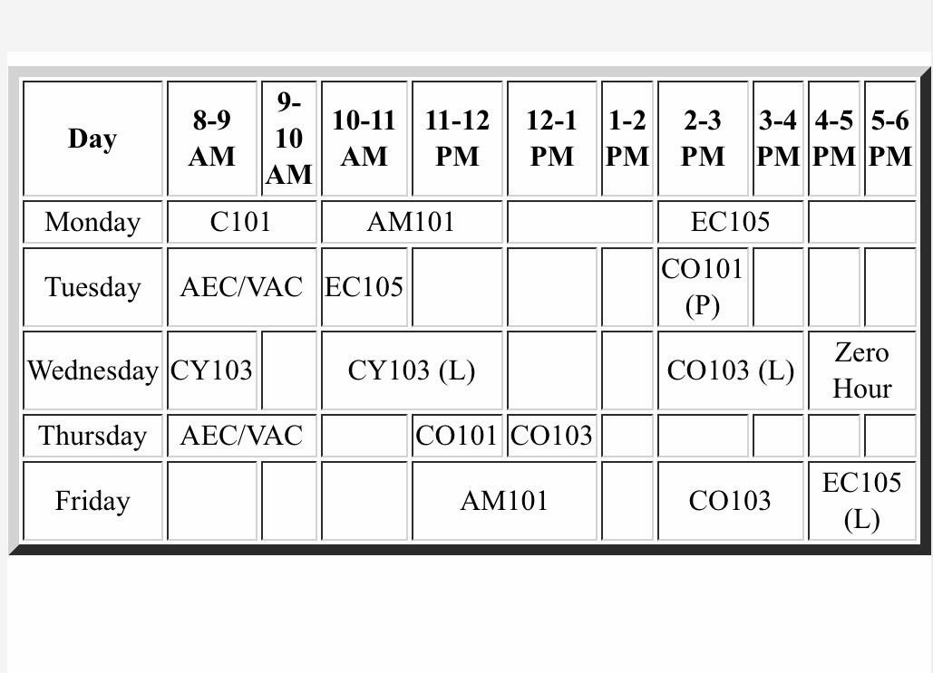

Experiment-5
Aim: Displaying an image in different formats
Code:
<!DOCTYPE html>
<html>
<head>
<title> Applying various attributes to an image</title>
</head>
<body style="background-color: #e0e0e0;">
<h2 style="text-align: center;"> Displaying images in various ways</h2> <hr>
<p>
Displaying the alternate text when the image is not found:
<br>
<img src="A:\HTML\Moon vie.png" alt="Panaromic view of moon">
</p>
<p>
Displaying the image with height and width attributes
<br>
<img src="A:\HTML\Moon view.png" alt="Panaromic view of moon" height="300" width="500">
</p>
<p>
Displaying an image by specifying the url
<br>
<img src ="https://images.unsplash.com/photo-1669729026928-
36afe1390851?q=80&w=880&auto=format&fit=crop&ixlib=rb-
4.1.0&ixid=M3wxMjA3fDB8MHxwaG90by1wYWdlfHx8fGVufDB8fHx8fA%3D%3D" alt="Panaromic view of moon" height="300" width="500">
</p>
<p>
Displaying an image as a detailed description about it <br>
<a href="https://simple.wikipedia.org/wiki/Moon"> <img
src="https://upload.wikimedia.org/wikipedia/commons/thumb/e/e4/Moon_merged_small.jpg/500px-
Moon_merged_small.jpg" alt="Panaromic view of moon" height="300" width="500"> </a>
</p>
<p>
Specifying image with Absolute Address
<br>
<img src="https://plus.unsplash.com/premium_photo-1685697414658ba6e19f7b308?q=80&w=1203&auto=format&fit=crop&ixlib=rb-
4.1.&ixid=M3wxMjA3fDB8MHxwaG90by1wYWdlfHx8fGVufDB8fHx8fA%3D%3D" alt="Panaromic view of moon" height="300" width="500">
<br>
</p>
<p>
Specifying image with Relative Address
<br>
<img src="Moon.png" alt="Panaromic view of moon" height="300" width="500" >
</p>
</body>
</html>
Output:
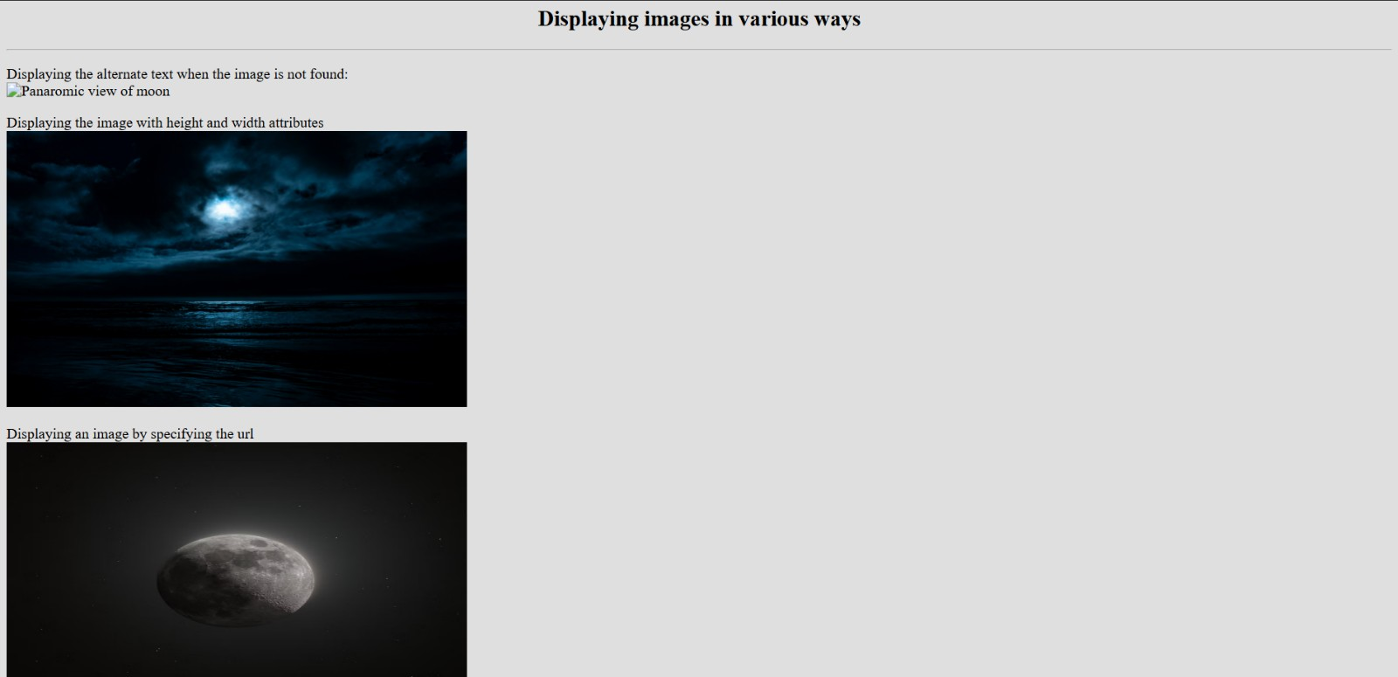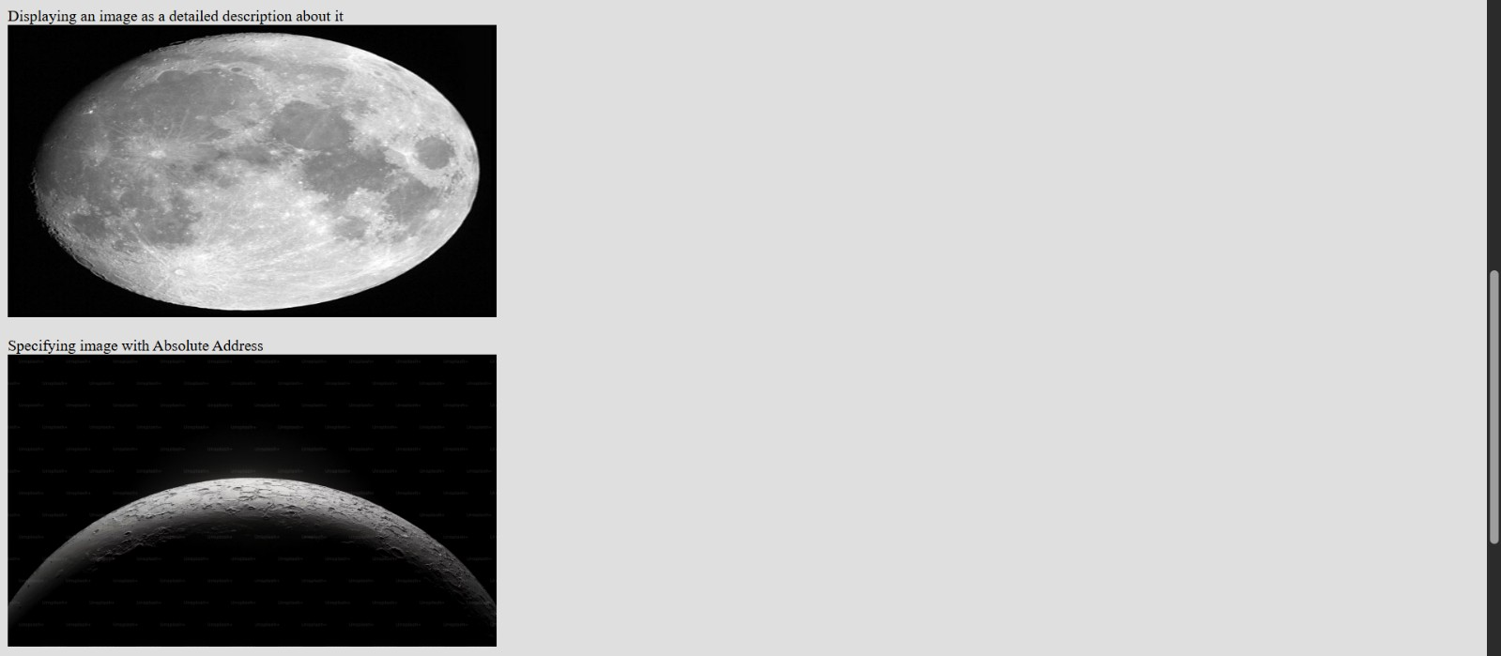
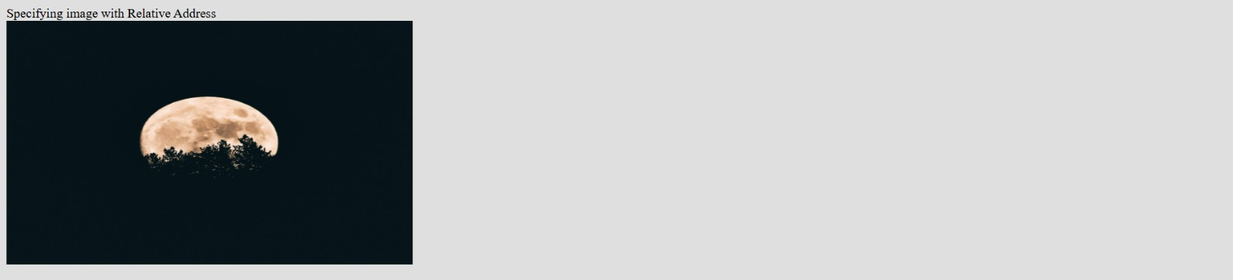

Experiment-6
Aim: Designing a simple to create an e-mail account
Code:
<!DOCTYPE html>
<html>
<head>
<title>Email Account Creation Form</title>
</head>
<body style="font-family: Arial; background: #f2f2f2; padding: 40px;">
<h2 style="color: #333; text-align:center;">Create Your Email Account</h2>
<form style="background: #fff; border: 1px solid #ccc; padding: 24px;">
<label for="fullname" >Full Name:</label>
<input type="text" id="fullname" name="fullname" >
<label for="email" >Email Address:</label>
<input type="email" id="email" name="email" >
<label for="password" >Password:</label>
<input type="password" id="password" name="password" >
<label for="confirm" >Confirm Password:</label>
<input type="password" id="confirm" name="confirm" >
<br> <br>

<label for="phone" >Phone Number:</label>
<input type="tel" id="phone" name="phone" >
<input type="submit" value="Create Account" >
</form>
</body>
</html>
Output:
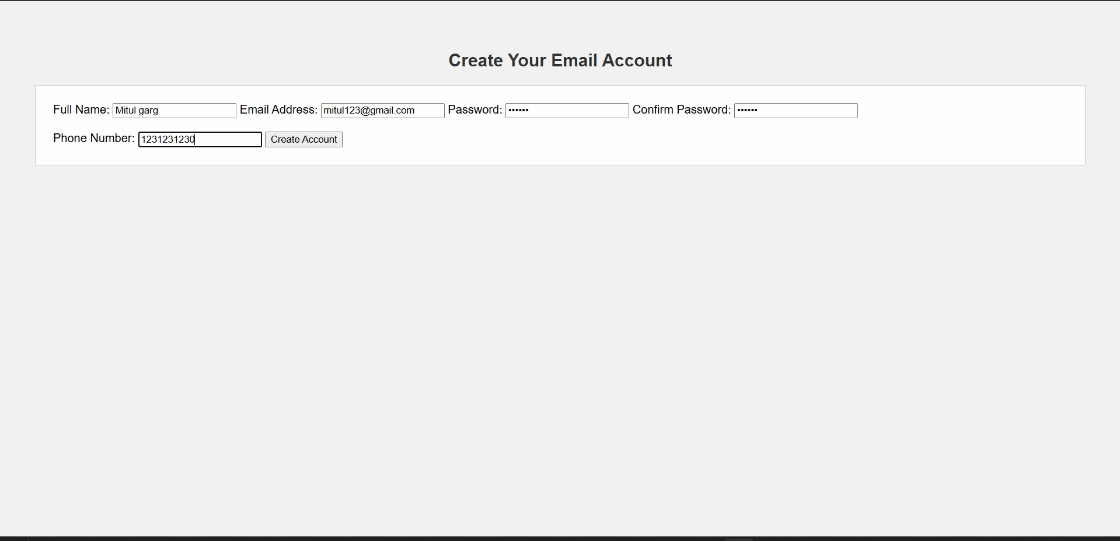

Experiment-7
Aim: Web page to link :
- A different web page of the same site.
- A different location on the same web page.
- A specific location on the different web page of the same site.
Code:
Code for the first file:
<!DOCTYPE html>
<html>
<head>
</head>
<body>
<h4><u> Contents </u></h4>
<ul>
<li> <a href="#a">Bridging geographical distances</a></li>
<li><a href="#b"> Building and empowering communities</a></li>
<li><a href="#c">Enhancing communication and emotional support </a></li>
<li><a href="#d"> Fostering creativity and learning</a></li>
</ul>

<h1>The Positive Connections of Social Media</h1>
<p>Social media, when used mindfully, serves as a powerful instrument for fostering positive human connections.
Rather than merely a source of distraction, these platforms can transcend geographical barriers, build communities
, and offer crucial support systems, ultimately enriching our relationships and expanding our social world.</p>
<h2>Bridging geographical distances</h2>
<p id="a">One of social media's most significant achievements is its ability to shrink the globe. Family and friends who are separated by continents can remain an active part of each other's lives through instant messaging, video calls, and photo sharing. This constant connection helps maintain relationships that might have otherwise faded due to distance, ensuring that loved ones stay emotionally connected despite the miles between them.</p>
<h2>Building and empowering communities</h2>
<p id="b">Social media allows people to discover and connect with like-minded individuals, creating vibrant communities built around shared interests, hobbies, and goals. From niche fan groups to support networks for specific health conditions, these online communities provide a sense of belonging and solidarity that can be especially valuable for people who feel isolated in their offline lives. By offering a platform for sharing experiences, social media empowers marginalized voices and amplifies movements for social change, proving that collective voices hold power.</p>
<h2>Enhancing communication and emotional support</h2>
<p id="c">For many, social media provides a comfortable space to engage in conversations that might be difficult face-to-face. It offers a lifeline for those who struggle with social anxiety or simply need a safe, anonymous place to seek support and encouragement.
By allowing users to find empathy from others who have gone through similar struggles, social media can strengthen emotional bonds and provide a crucial support system.</p>
<h2>Fostering creativity and learning</h2>
<p id="d">Social media serves as a global stage for creative expression, enabling individuals to share their artistic pursuits, writing, and music with a vast audience. Beyond a creative outlet, it also offers endless educational opportunities. Users can access tutorials, online courses, and informative content, empowering them to learn new skills or deepen their knowledge in a variety of fields. This shared pursuit of knowledge and skill-building can also forge stronger bonds among people with common intellectual curiosities.</p>
<p>In sum, when approached with intentionality and balance, social media's capacity for good is immense.
It is a tool that allows us to build and maintain relationships across great distances, form supportive communities, and find our voice in a global conversation. By focusing on its power to connect rather than its potential
to divide, we can continue to harness social media's positive potential for human connection.</p>
To learn about the negatives of social media <a href="b.html"> click here.</a> It contains:
<ul>
<li> <a href="b.html#f"> The Mental Health Crisis</a></li>
<li><a href="b.html#g">Erosion of Authentic Connection</a></li>
<li><a href="b.html#h">Spread of Misinformation and Echo Chambers</a></li>
<li><a href="b.html#i">Cyberbullying and Privacy Risks</a></li>
<li><a href="b.html#j">Addictive Nature of Platforms</a></li>
</body>
</html>

Code for second file:
<!DOCTYPE html>
<html>
<head>
</head>
<body>

<h1>The Negative Impact of Social Media</h1>
<p id="e">While social media promises connection, its pervasive and uncritical use can lead to serious negative consequences, from mental health issues and addiction to the erosion of genuine human interaction and the spread of misinformation.
By examining the darker side of these platforms, we can better understand the societal and individual costs that often go overlooked in the rush for digital engagement.</p>
<h2>The Mental Health Crisis</h2>
<p id="f">Social media has been linked to a rise in mental health problems, particularly among adolescents and young adults.
Constant exposure to carefully curated, idealized lives creates a cycle of upward social comparison, leading to
feelings of inadequacy, envy, and low self-esteem. This "compare and despair" cycle, amplified by the pressure to present a perfect online persona, can significantly contribute to anxiety and depression.</p>
<h2>The Erosion of Authentic Connection</h2>
<p id="g">The very platforms designed to connect us can paradoxically increase feelings of loneliness and isolation.
The sheer volume of digital interactions often replaces deeper, face-to-face relationships, which are essential for mental well-being. This shift can lead to superficial connections and a decline in meaningful interpersonal skills, as users prioritize their online interactions over real-world engagement.</p>
<h2>The Spread of Misinformation and Echo Chambers</h2>
<p id="h">Social media algorithms are designed to maximize engagement, often by feeding users more of what they already agree with. This creates echo chambers where users are only exposed to information that confirms their existing beliefs, making them more susceptible to misinformation and disinformation. The viral nature of social media
allows false or misleading narratives to spread rapidly, distorting public discourse and eroding trust in credible information sources.</p>
<h2>Cyberbullying and Privacy Risks</h2>
<p id="i">Social media provides a fertile ground for cyberbullying and online harassment, with individuals often hiding behind anonymity to inflict emotional harm. The pervasive nature of these platforms means that harassment can be relentless, with no safe space for escape. Additionally, social media platforms continuously collect vast amounts of personal user data, raising significant privacy concerns and exposing users to risks like targeted advertising, data breaches,
and identity theft.</p>
<h2>The Addictive Nature of Platforms</h2>
<p id="j">Social media is engineered to be addictive, utilizing psychological triggers such as variable reward systems to create a dopamine-driven feedback loop. This leads to compulsive checking and endless scrolling, which can result in decreased productivity, disrupted sleep, and an inability to focus on real-world tasks.</p>
<p>In conclusion, while social media offers certain advantages, its negative aspects present a formidable challenge to individual well-being and a healthy society. Addressing these issues requires a critical approach to how we
engage with technology, prioritizing mental health, fostering authentic connections, and demanding greater accountability from the platforms that shape our digital lives.</p>
</body> </html>
Output:

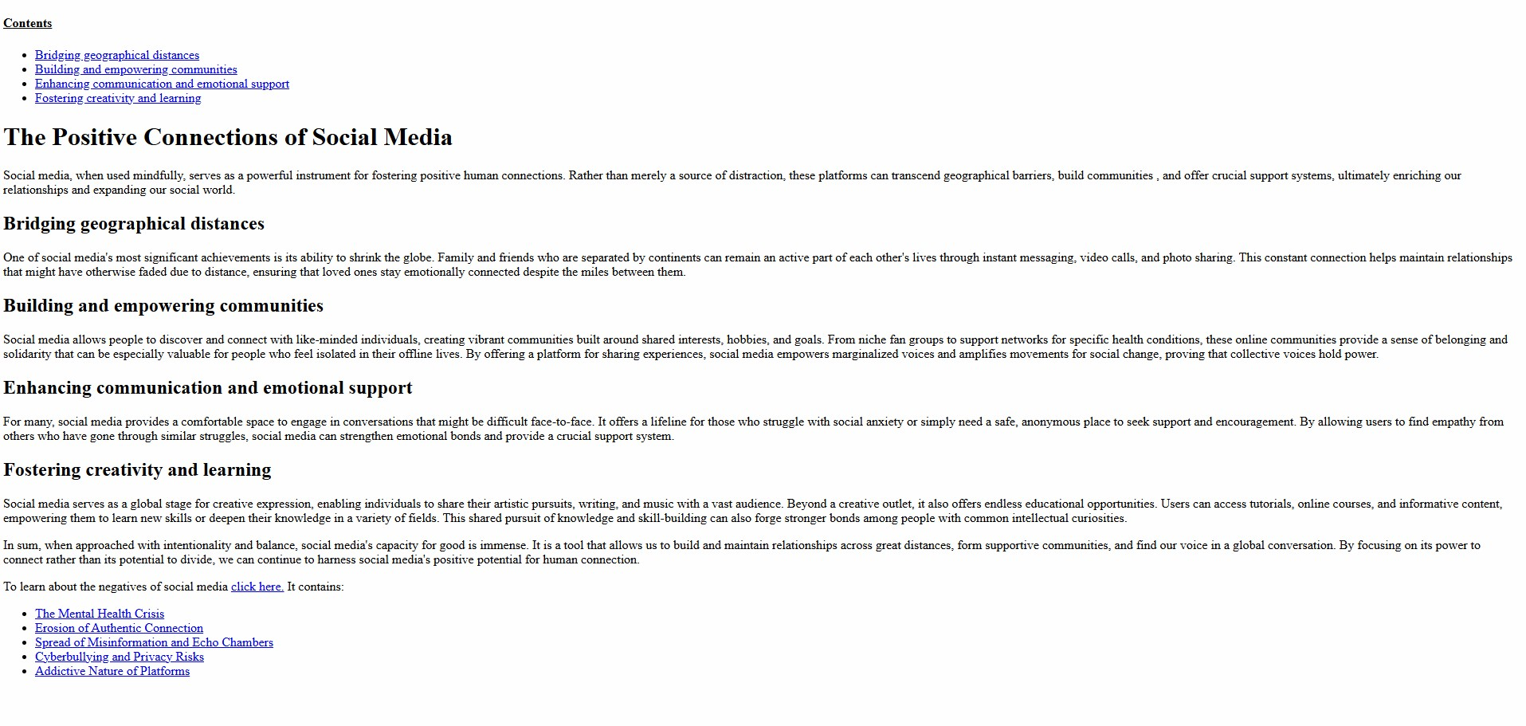
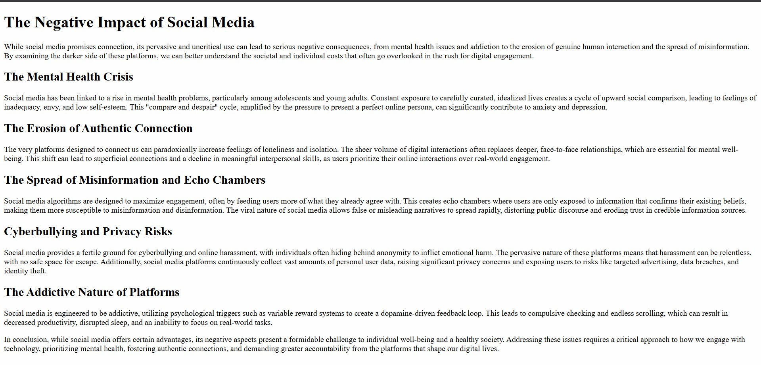

Experiment-8
Aim: Displaying functionality of using external CSS
Code:
Code of HTML file:
<!DOCTYPE html>
<html>
<head>
<title>Nature</title>
<link rel="stylesheet" href="b.css">
</head>
<body>
<h1>The Beauty of Nature</h1>
<p>
Nature is an incredible gift that surrounds us every day. From towering trees in forests to calm rivers and colorful flowers, nature fills our world with beauty and wonder. It provides a peaceful escape from busy city life and reminds us to appreciate the simple things. </p>
<p>
All living creatures, including humans, depend on nature for air, water, and food. Spending time outdoors helps us relax and feel connected to the environment. Taking care of nature is important so that future generations can enjoy its beauty and resources, too. </p>
<p>
The changing seasons show the diversity of nature. In spring, plants bloom with new life, while autumn paints the leaves with vibrant colors. Each season brings its own sights and experiences, making nature interesting all year round.
</p>
<p>
Protecting nature is everyone's responsibility. Small actions like planting trees, reducing waste, and conserving water help keep the environment healthy. By respecting nature, we make the world a better place for every living being.
</p>
</body>
</html>
Code of CSS file: body {
line-height: 1.6; margin: 20px; background-color: #e6f2ff; color: #333333;
}
h1 { color: #2e8b57; text-align: center; margin-bottom: 20px;
}
p { color:darkblue; font-size: 16px; margin-bottom: 15px; width: 75%; text-align: justify; }
Output:
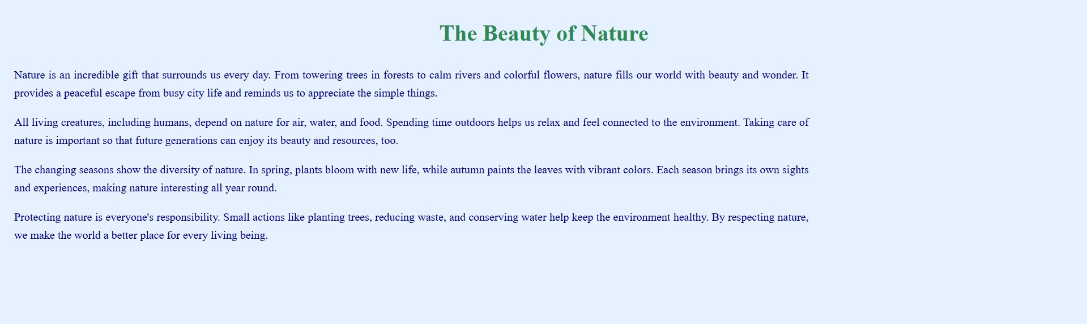
Experiment-9
Aim: Displaying text on top of an image using overlay
Code:
<!DOCTYPE html>
<html>
<head>
<style> body { background-color: bisque;
}
.container { position: relative; width: 50%; margin: 0 auto;
}
.image { display: block; width: 100%; height: auto;
}
.overlay { position: absolute; top: 0; bottom: 0;
left: 0; right: 0; height: 100%; width: 100%; opacity: 0; transition: .5s ease; background-color: #008CBA;
}
.container:hover .overlay { opacity: 1;
}
.text { color: white; font-size: 20px; position: absolute; top: 50%; left: 50%; text-align: center;
}
</style>
</head>
<body>
<h2>Overlay</h2>
<p>There's something hidden in the image.</p>
<div class="container">
<img src="https://media.istockphoto.com/id/1503858430/vector/website-software-development-conceptweb-design-site-and-mobile-app-on-laptop-testingon.jpg?s=612x612&w=0&k=20&c=k8ckKsgOrPPxohAA_ywg2VXZzdCPptEbOlleRV8Kb7c=" alt="Pic" class="image">
<div class="overlay">
<div class="text">Web Dev!</div>
</div>
</div>
</body>
</html>
Output:

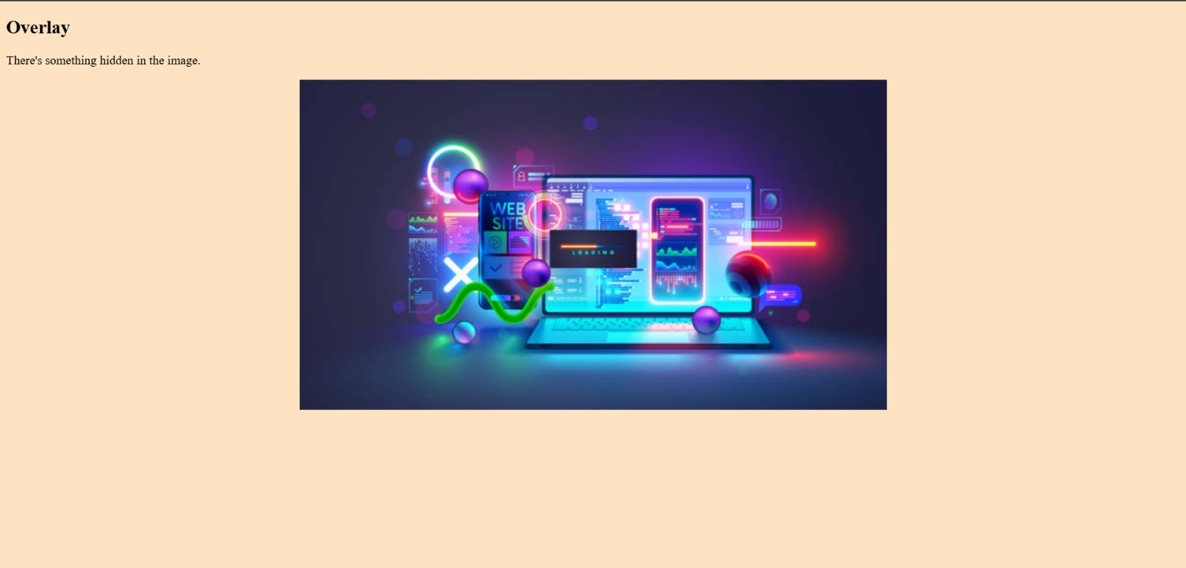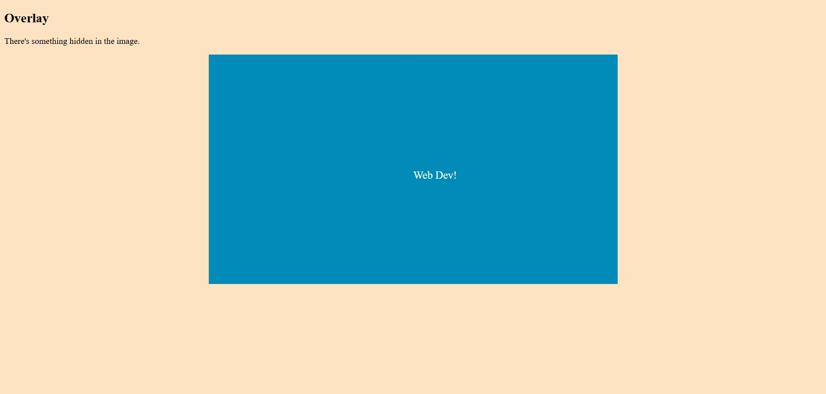

Experiment-10
Aim: Changing the styling of text selection
Code:
HTML file:
<!DOCTYPE html>
<html>
<head>
<title>Nature</title>
<link rel="stylesheet" href="selection.css">
</head>
<body>
<h1>The Beauty of Nature</h1>
<p>
Nature is an incredible gift that surrounds us every day. From towering trees in forests to calm rivers and colorful flowers, nature fills our world with beauty and wonder. It provides a peaceful escape from busy city life and reminds us to appreciate the simple things. </p>
<p>
All living creatures, including humans, depend on nature for air, water, and food. Spending time outdoors helps us relax and feel connected to the environment. Taking care of nature is important so that future generations can enjoy its beauty and resources, too. </p>
<p>
The changing seasons show the diversity of nature. In spring, plants bloom with new life, while autumn paints the leaves with vibrant colors. Each season brings its own sights and experiences, making nature interesting all year round.
</p>
<p>
Protecting nature is everyone's responsibility. Small actions like planting trees, reducing waste, and conserving water help keep the environment healthy. By respecting nature, we make the world a better place for every living being.
</p>
</body>
</html> CSS file: body {
line-height: 1.6; margin: 20px; background-color: #e6f2ff; color: #333333;
}
h1 { color: #2e8b57; text-align: center; margin-bottom: 20px;
}
p { color:darkblue; font-size: 16px; margin-bottom: 15px; width: 75%; text-align: justify; }
::selection { background: #f41717;
color: #ffffff; }
Output:
